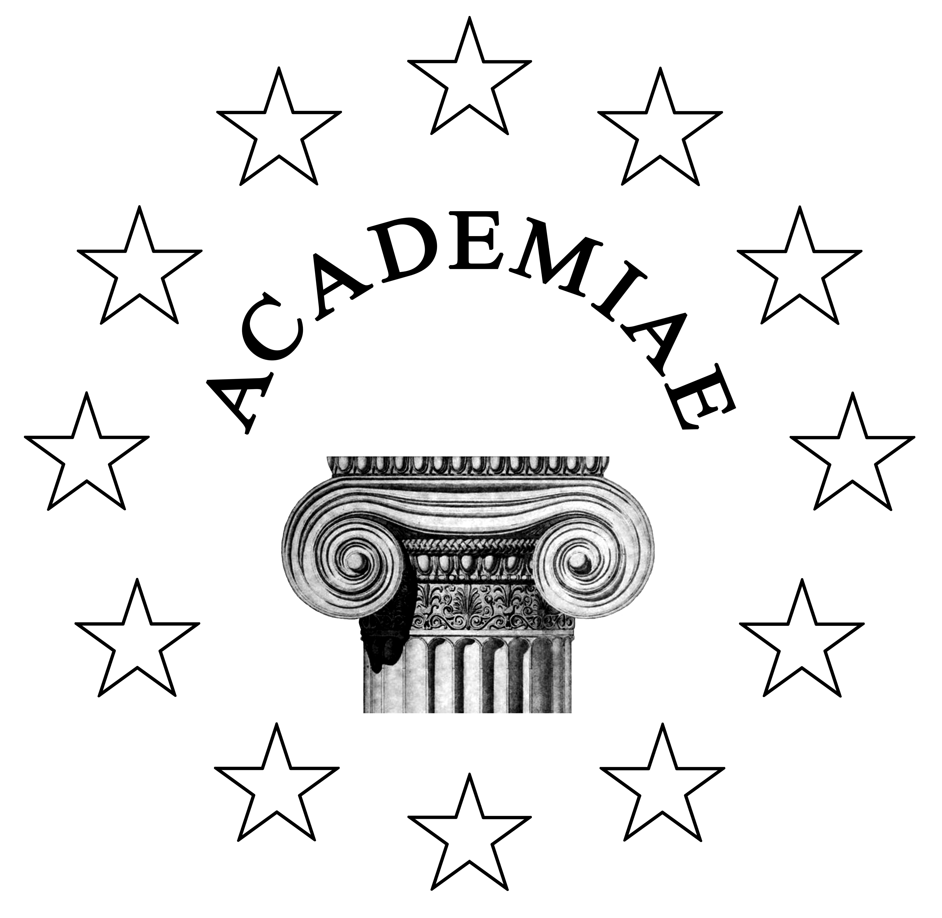
EUROCLASSICA - ACADEMIA SAGUNTINA QUARTA
1. CUR - Introduction
One of the most important aims of EUROCLASSICA (Fédération européenne des associations de professeurs de langues et de civilisations classiques) is to make pupils and students aware of the European dimension of Classics. The ACADEMIA SAGUNTINA, European School in Classical Civilisation, will bring together young people from different European countries up to Saguntum (Valencia)-SPAIN in order to work in a very active and practical way on daily life in ancient Rome and on ancient Greek drama.
2. QUANDO - Date
2016, July ,Sunday 3th - Sunday 10th .
3. UBI - Location
The Academia will be located at Hotel Vent de Mar, Sagunto, Valencia (Spain)
4. QUIBUS - Participants
ACADEMIA SAGUNTINA is addressed to students taking courses in Latin and/or Greek and/or Classical Civilisation and/or Classical Theatre at Secondary School. Most of the students are supposed to be aged 16-18 or 17-19
5. QUID - Topics
Participants will achieve three different activities:
- Instructional tour of Saguntum, ancient urbs foederata to Rome
- Workshops in Roman Civilisation at the so called Domus Baebia (from 10:00 to 13:30)
- Workshops in Ancient Greek Drama;final presentation on the Ancient Roman Theater of Saguntum (from19:00 to 21:30)
A more detailed time-table together with further detailed information will be sent to all the participants.
6. QUIS - Teachers
- Instructional tour and workshops at Domus Baebia: Charo Marco, Amparo Moreno
- Workshops on Greek Drama: Gemma López, José Luis Navarro
- Director: José Luis Navarro.
7. QUANTO - Price
Fee for ACADEMIA SAGUNTINA is 350 Euros.
This price includes tuition, workshops, instructional tour, accommodation in air conditioned double rooms equipped with full bathroom and a fridge on half-board ( breakfast-dinner) bases at hotel Vent de Mar.
N.B. Travel to and from Saguntum is not included.
8. QUO MODO - Language
Most lessons and activities will be achieved in English. French or Spanish can be eventually used.
9. QUIBUS AUXILIIS - Sponsors and cooperators
- EUROCLASSICA
- Consellería Educación Generalitat Valenciana
- Ayuntamiento de Sagunto
- Domus Baebia
- CEFIRE
- Hotel Vent de Mar
- Asociación Ludere et Discere
10. INSCRIPTION
Those who want to participate must fill up the inscription form and send it before may 15th, 2016 to academiasaguntina@gmail.com
Students who will be accepted will receive further information in due time.
In case you have any doubt do not hesitate to contact us at
academiasaguntina@gmail.com or

navarrakis@hotmail.com
Applications on line will be welcome.Click www.euroclassica.eu and follow the link ACADEMIAE.
APPLICATION FORM

- NAME:
- SURNAME:
- BIRTH DATE:
- ADDRESS:
- MOBILE PHONE:
- E-MAIL:
- SCHOOL:
- SUBJECTS: Latin: Yes/No
Greek: Yes /No
Classical Civilisation: Yes/No
Others related to Classical World:

