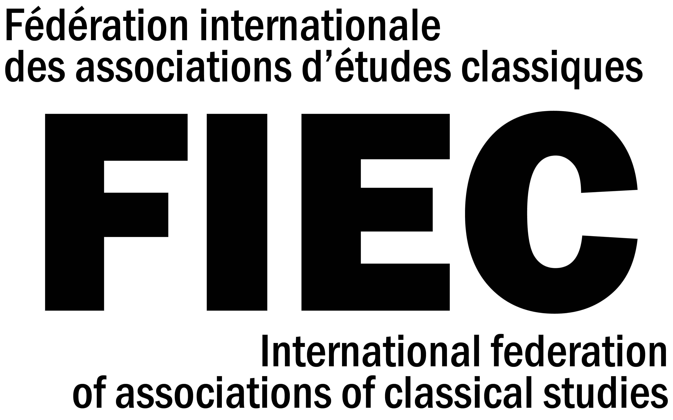

The Secretary General’s report from January 1st to December 31st, 2019

1. Reminder : contact between FIEC and affiliated associations
There are currently 75 associations of Classical studies affiliated to FIEC. Staying in touch with all of them remains a difficult task. It is therefore of the utmost importance that associations send us a regular update of their contact address (postal, e-mail and URL of website if available, to be sent to : sabine.huebner@unibas.ch).

2. Payment of yearly fee
All affiliated associations are reminded that the annual membership fee is € 110.-, to be paid as soon as possible. The resources of FIEC are very scarce; any contribution above the minimal amount of € 110.- will be deeply appreciated.
Following the changes decided at the Leiden General Assembly (2017), FIEC’s bank account is now based in Switzerland (labelled in euros). Instructions for payment are to be found on the Treasurer’s invoice.

3. FIEC website
Please remember to check our FIEC website: www.fiecnet.org which includes a blog (http://fiecnet.blogspot.ch), to which all can contribute. If the information displayed needs an update, please let us know. Please also follow us on Facebook (https://www.facebook.com/FIECnews/) and Twitter (https://twitter.com/FIECnews).
FIEC’s social media profiles are being maintained with the help of Simon Raith (Basel), who deserves our warmest thanks for the work. You may send contents to Sabine Huebner (sabine.huebner@unibas.ch).

4. Recent FIEC activities
FIEC is the umbrella organization representing Classical Studies worldwide. In that capacity, it has contacted governmental authorities in several countries where a closing or downsizing of Classical Studies was being considered. Since the FIEC General Assembly in London (July 4, 2019), the newly elected Board has been trying to support Classical studies in several parts of the world, especially in cases where an institution or a government was considering closing a program or an institute.

Martha Irigoyen (Vice-President), Jesús de la Villa (Board member) and Sabine Huebner (Secretary General) thus sent a statement on behalf of FIEC to help prevent the Swedish ministry of education from excluding ancient history from its school curricula. In the following, the Swedish government informed Sabine Huebner that they were no longer pursuing this plan.

Gunhild Vidén (FIEC President) wrote in the name of FIEC to the University of Basel on the occasion of ongoing discussions about the replacement of the position of Latin and Greek philology. She stressed the importance of a strong presence of classical philology at Basel as home of Erasmus with its long tradition of Humanist education.

FIEC has also endorsed the fundraising campaign for papyri.info launched by the Association Internationale de Papyrologues (AIP) and the American Society of Papyrologists (ASP). The call for donations is available via this website (https://www.supportpapyri.info/) and is directed to all individuals, institutions and funding agencies, asking them to help us to ensure that scholars and students in papyrology and related disciplines can continue to benefit from this important resource over the coming decades.

FIEC also supported the appeal to support the Querini Stampalia Foundation which suffered severe damage as a result of the exceptional flood that struck the city of Venice on the night of 12 November 2019.

Sabine Huebner (Secretary General) took over FIEC’s website (www.fiecnet.org) and social media profiles (https://www.facebook.com/FIECnews/ and https://twitter.com/FIECnews) and, with the help of a competent student, is keeping it up to date. Please send her any relevant information that would be useful. She is also working on some improvement to the website.

André Lardinois (board member) informed the FIEC board that the EASSH (European Alliance for Social Sciences and Humanities) plans to increase its membership fees by 25%. The FIEC board unanimously voted to accept this increase and remain a member the EASSH which is lobbying for a stronger presence of the humanities in Horizon Europe, the next European research and innovation framework programme.
Fausto Montana (board member) attended as FIEC Delegate the general assembly of the L’Année Philologique which took place in Paris on October 19, 2019.

Martha Irigoyen is presiding over the preparations for the next 16th FIEC Congress & General Assembly to be held in Mexico in 2022. She has started her fundraising campaign (more infos?).

5. FIEC Congresses and General Assemblies
After the very successful FIEC Congress (July 5-8, 2019) and General Assembly (July 4, 2019) in London – for which all organizing members of the the Classical Association and the Societies for the Promotion of Hellenic and Roman Studies should once more be warmly thanked – further steps were taken towards the preparation of the next FIEC Congresses, following a 3-year cycle (each time with a Congress and a General Assembly).
The 16th FIEC Congress & General Assembly which is jointly organized by the Instituto de Investigaciones Filológicas at UNAM, its Center of Classical Studies and the Associación Mexicana de Estudios Clásicos (AMEC) will be held in Mexico City from August ????, 2022. Our Mexican colleagues should be thanked for their willingness to host this congress, to which we all look forward.
Sabine Huebner has received an offer from the board of the Polish Philological Association to host the 17th FIEC Congress & General Assembly in Wrocław (Poland) in summer 2025. The FIEC board has unanimously welcomed this proposal.

7. Meeting of the FIEC Board
The next meeting of the FIEC board will take place on September 11, 2020 in Mulhouse (France).

The Secretary General : Sabine Huebner
Basel, January 16, 2020

